Dynamic Power Network Management Using Graph, BFS and Kruskal’s Algorithm
Problem statement:
Develop a C++ program to represent a power network using a graph, where power substations are represented as vertices and power lines are represented as weighted edges. Apply Breadth-First Search (BFS) to check the reachability of substations from a selected starting substation. If the graph is connected, apply Kruskal’s algorithm to calculate the Minimum Spanning Tree (MST) and its minimum total cost. If the graph is disconnected, display an appropriate message.

Objectives:
- To represent power substations as vertices and power lines as weighted edges using a graph.
- To modify the graph dynamically by adding new substations or power lines.
- To display the updated graph after every modification.
- To apply Breadth-First Search (BFS) to check the reachability of substations.
- To compare BFS traversal results before and after graph updates.
- To apply Kruskal’s algorithm to calculate the Minimum Spanning Tree (MST) cost.
- To compare MST costs before and after modifications.
- To detect disconnected substations and display an appropriate message when an MST or path is unavailable.

Algorithm:
1.Start the program.
2.Input the number of substations and power lines.
3.Store substations as vertices and power lines as weighted edges.
4.Display the original graph.
5.Perform BFS from a selected substation and check connectivity.
6.If the graph is connected, calculate the MST cost using Kruskal’s algorithm; otherwise, display that an MST does not exist.
7.Allow the user to add a new substation or a new power line.
8.Display the updated graph.
9.Repeat BFS and Kruskal’s algorithm on the updated graph.
10.Compare the original and updated traversal and MST results.
11.Display the results and stop.

Flowchart: 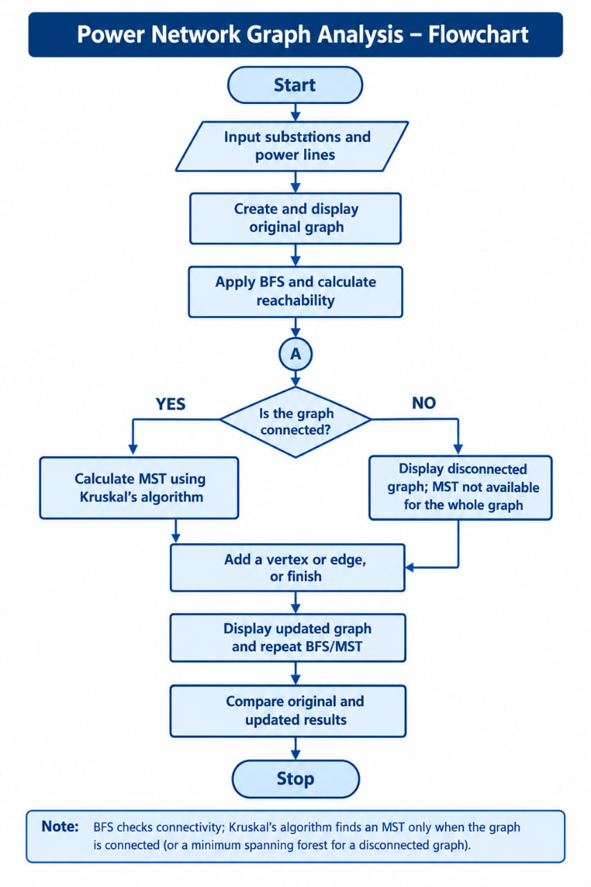
Code:

#include <iostream>
#include <vector>
#include <queue>
#include <algorithm>
using namespace std;
struct Edge
{
int u, v, w;
};

bool compareEdges(Edge a, Edge b)
{
return a.w < b.w;
}
class PowerNetwork
{
int n;
vector<Edge> edges;
vector<vector<int> > adj;
public:
PowerNetwork(int vertices)
{
n = vertices;
adj.resize(n);
}
int vertexCount()
{
return n;
}
void addVertex()
{
n++;
adj.resize(n);
cout << "New substation added: "
<< n - 1 << endl;
}
void addEdge(int u, int v, int w)
{
if (u < 0 || v < 0 || u >= n ||
v >= n || u == v || w < 0)
{
cout << "Invalid power line!" << endl;
return;
}
Edge e;
e.u = u;
e.v = v;
e.w = w;

edges.push_back(e);
adj[u].push_back(v);
adj[v].push_back(u);
cout << "Power line added successfully."
<< endl;
}
void displayGraph()
{
int i, j;
cout << "\nAdjacency List:" << endl;
for (i = 0; i < n; i++)
{
cout << "Substation " << i << ": ";
for (j = 0; j < (int)adj[i].size(); j++)
cout << adj[i][j] << " ";
cout << endl;
}
cout << "\nPower Lines (u-v : cost):"
<< endl;
for (i = 0; i < (int)edges.size(); i++)
{
cout << edges[i].u << " - "
<< edges[i].v << " : "
<< edges[i].w << endl;
}
}
int BFS(int start)
{
if (start < 0 || start >= n)
{
cout << "Invalid starting substation."
<< endl;
return -1;
}
vector<bool> visited(n, false);
queue<int> q;
int count = 0;

visited[start] = true;
q.push(start);
cout << "BFS traversal: ";
while (!q.empty())
{
int u = q.front();
q.pop();
cout << u << " ";
count++;
for (int i = 0;
i < (int)adj[u].size(); i++)
{
int v = adj[u][i];

if (!visited[v])
{
visited[v] = true;
q.push(v);
}
}
}
cout << "\nReachable substations: "
<< count << " out of " << n << endl;
if (count == n)
cout << "Network is connected." << endl;
else
cout << "Network is disconnected."
<< endl;
return count;
}
int findParent(vector<int>& parent, int x)
{
if (parent[x] == x)
return x;
parent[x] = findParent(parent, parent[x]);
return parent[x];
}
bool unite(vector<int>& parent,
vector<int>& rankSet, int u, int v)
{
u = findParent(parent, u);
v = findParent(parent, v);
if (u == v)
return false;
if (rankSet[u] < rankSet[v])
parent[u] = v;
else if (rankSet[u] > rankSet[v])
parent[v] = u;
else
{
parent[v] = u;
rankSet[u]++;
}
return true;
}

int kruskal()
{
vector<Edge> sorted = edges;
sort(sorted.begin(), sorted.end(),
compareEdges);
vector<int> parent(n);
vector<int> rankSet(n, 0);
int i, cost = 0, selected = 0;
for (i = 0; i < n; i++)
parent[i] = i;
cout << "\nMST Edges:" << endl;
for (i = 0;
i < (int)sorted.size() && selected < n - 1;
i++)
{
Edge e = sorted[i];
if (unite(parent, rankSet, e.u, e.v))
{
cout << e.u << " - " << e.v
<< " : Cost = " << e.w << endl;
cost += e.w;
selected++;
}
}

if (selected != n - 1)
{
cout << "MST unavailable: graph is "
<< "disconnected." << endl;
return -1;
}
cout << "Minimum MST cost = "
<< cost << endl;
return cost;
}
};
int main()
{
int n, m, i;
cout << "Enter number of substations: ";
cin >> n;
if (cin.fail() || n < 1)
{
cout << "Invalid number of substations."
<< endl;
return 0;
}
PowerNetwork p(n);
cout << "Enter number of power lines: ";
cin >> m;
if (cin.fail() || m < 0)
{
cout << "Invalid number of power lines."
<< endl;
return 0;
}
cout << "\nEnter power lines (u v cost):"
<< endl;
for (i = 0; i < m; i++)
{
int u, v, w;
cout << "Edge " << i + 1 << ": ";
cin >> u >> v >> w;
if (cin.fail())
{
cout << "Invalid input." << endl;
return 0;
}
p.addEdge(u, v, w);
}
cout << "\n===== ORIGINAL NETWORK =====" << endl;
p.displayGraph();
int start;
cout << "\nEnter starting substation (0 to "
<< n - 1 << "): ";
cin >> start;
if (cin.fail() || start < 0 || start >= n)
{
cout << "Invalid starting substation."
<< endl;
return 0;
}
cout << "\n===== ORIGINAL BFS =====" << endl;
int oldReach = p.BFS(start);
int oldCost = -1;
if (oldReach == p.vertexCount())
{
cout << "\n===== ORIGINAL MST =====" << endl;
oldCost = p.kruskal();
}
else
{
cout << "Original MST is unavailable."
<< endl;
}

int choice = 0;
do
{
cout << "\n===== UPDATE MENU =====";
cout << "\n1. Add new substation";
cout << "\n2. Add new power line";
cout << "\n3. Display current graph";
cout << "\n4. Finish updates";
cout << "\nEnter your choice: ";
cin >> choice;
if (cin.fail())
{
cout << "Invalid input." << endl;
return 0;
}
if (choice == 1)
{
p.addVertex();
}
else if (choice == 2)
{
int u, v, w;
cout << "Enter u v cost: ";
cin >> u >> v >> w;
if (cin.fail())
{
cout << "Invalid input." << endl;
return 0;
}
p.addEdge(u, v, w);
}
else if (choice == 3)
{
p.displayGraph();
}
else if (choice != 4)
{
cout << "Invalid choice." << endl;
}
} while (choice != 4);

cout << "\n===== UPDATED NETWORK =====" << endl;
p.displayGraph();
cout << "\n===== UPDATED BFS =====" << endl;
int newReach = p.BFS(start);
int newCost = -1;
if (newReach == p.vertexCount())
{
cout << "\n===== UPDATED MST =====" << endl;
newCost = p.kruskal();
}
else
{
cout << "Updated MST is unavailable."
<< endl;
}
cout << "\n===== BEFORE AND AFTER COMPARISON ====="
<< endl;
cout << "Original reachable substations: "
<< oldReach << endl;
cout << "Updated reachable substations: "
<< newReach << endl;
if (oldCost == -1)
cout << "Original MST cost: Unavailable"
<< endl;
else
cout << "Original MST cost: "
<< oldCost << endl;
if (newCost == -1)
cout << "Updated MST cost: Unavailable"
<< endl;
else
cout << "Updated MST cost: "
<< newCost << endl;
return 0;
}

Output: 